How to login to www.shalem.org to view and pay plans online

Create a Password and Login
(If you already have a Shalem account and know how to log in with your password, you can skip to the “View and Pay Online” section on page 4).

- Input your email address here: https://shalem.org/paupress/?rel=lost
(If you have more than one email address, make sure it is the email where you receive Shalem eNews monthly.)
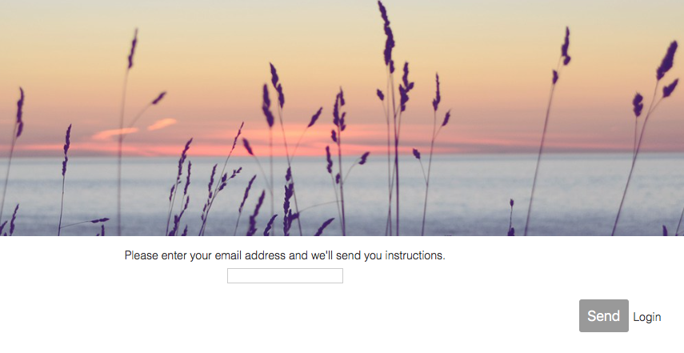
- Check your email for a message from info@shalem.org with subject line Password Reset. If you do not see this email, check your spam folder and add info@shalem.org to your address book in your email. Then, try step 1 again to get sent another email.
Click the link in the email and choose a password for logging into shalem.org.
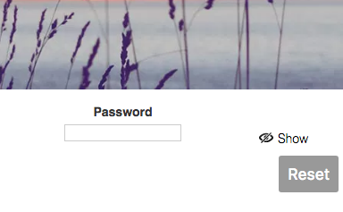
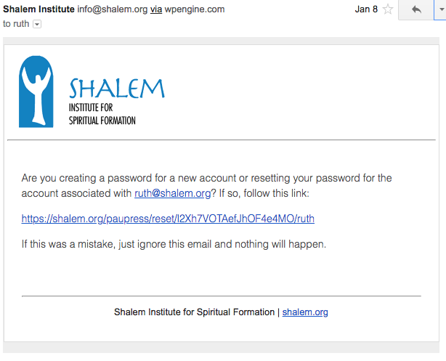

- You should automatically be directed to login. Input your email and password and press Login. If not, go here to login: https://shalem.org/paupress/login
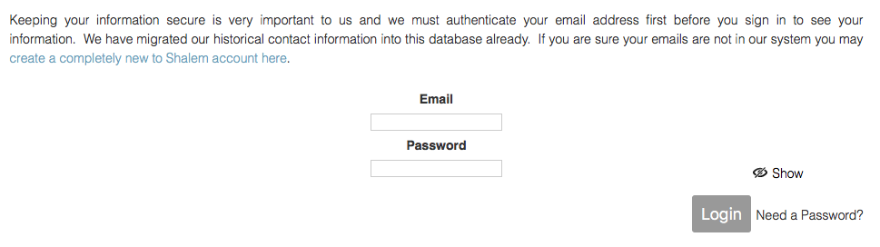

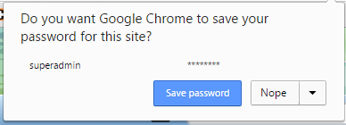
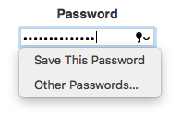
- If your browser prompts you to remember the password, we recommend saying yes if you are on a trusted computer.

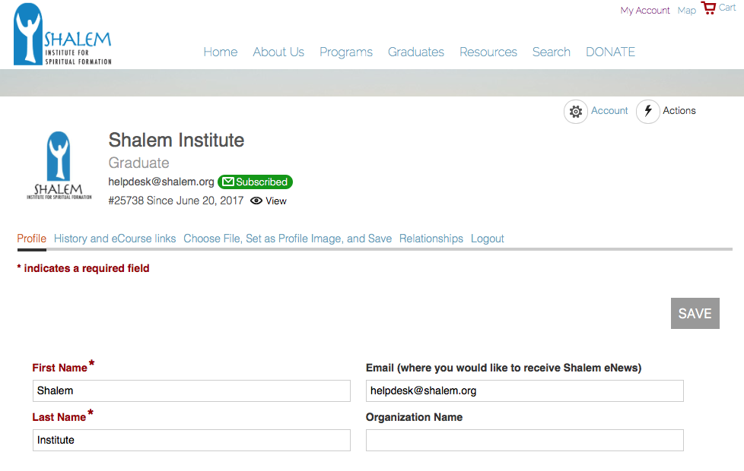
Once you are logged in, you can visit your profile from any shalem.org webpage by clicking My Account in the top header.

- Feel free to update any profile information and press SAVE.

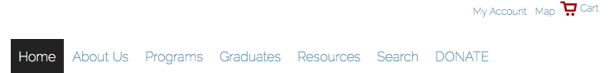
View and Pay Online
- Once logged on My Account page: Click on the tab beside Profile (the History and eCourse links tab).
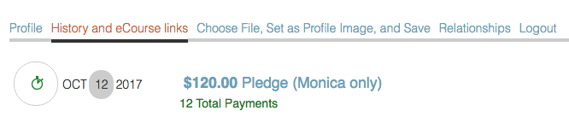

Look for financial history items (icon for one time purchases and icon for installment multiple purchase plans) At this point, you can pay online for the installment plans (not one time purchases):
- Click on the Title of the financial item to see the slide screen detail.
Find the Pay button.
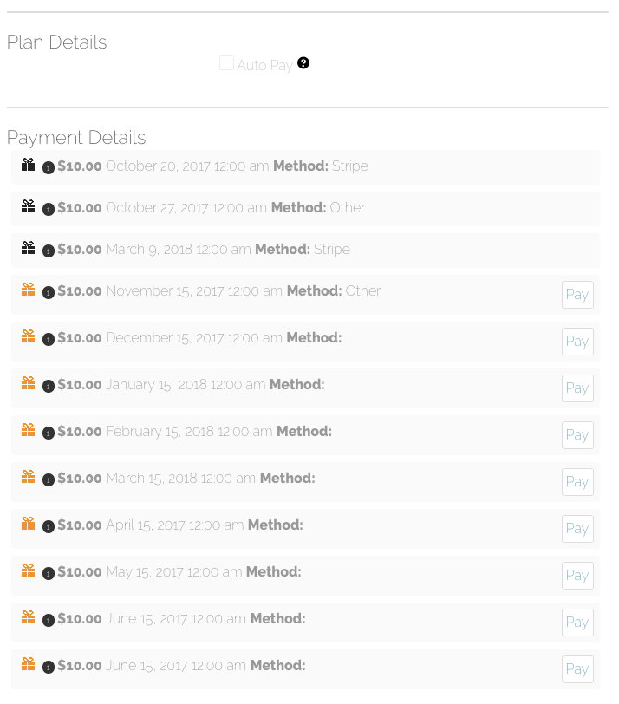
Installments/Pledges/Plans look like this:

- Click Pay on the item you would like to pay.
We accept Visa, MasterCard, American Express, JCB, Discover, and Diners Club.
Black icons denote completed payments. Orange denotes unpaid. The date seen is date paid or date due for completed and pending payments, respectively.
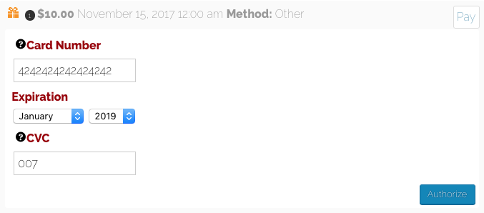
Click Authorize to pay.
This may take a moment to process.
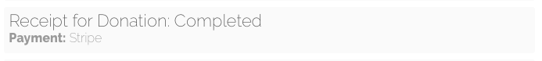
Do not press the button twice or close the screen while you see the progress bar:

If the progress bar continues for more than a few minutes, there may be an issue. Refresh the screen and see if the cart on your payment has turned black to confirm completed payment.

Check your email. You should receive a receipt from Stripe confirming payment. If you do not, please try again or contact trish at trish@shalem.org.

